13 Painted Kitchen Cabinet Ideas and How to Get a Pro Finish in 2026
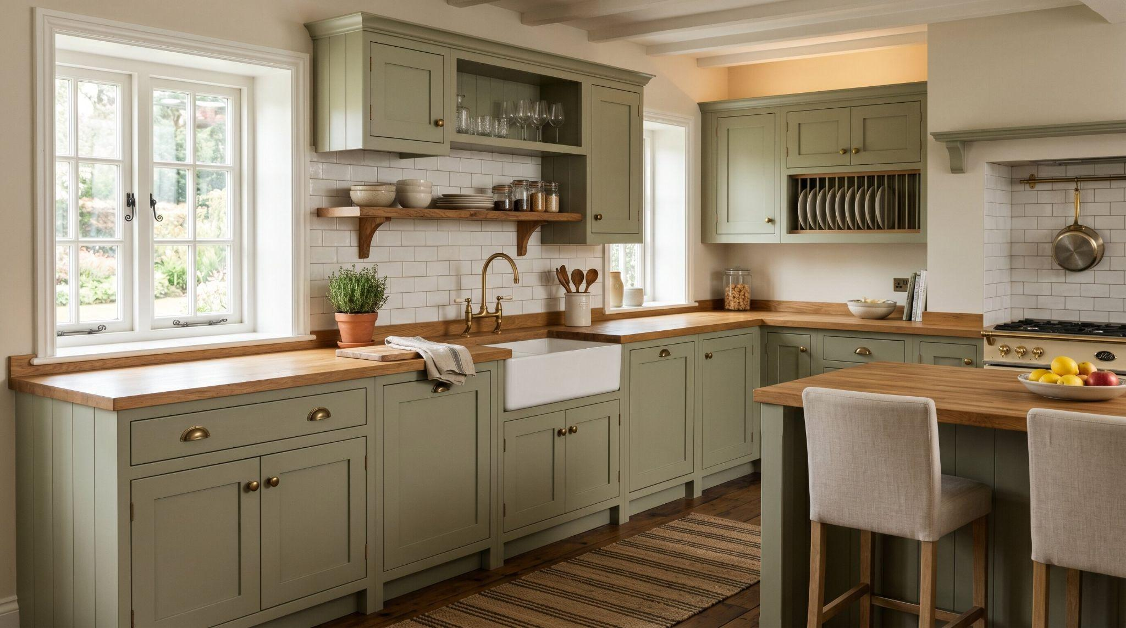
Traditional sage green kitchen with farmhouse sink, wood countertops, and warm rustic charm.
Painting your kitchen cabinets can save thousands of dollars compared with a full cabinet replacement, but the result only looks expensive when the color choice and finish are done carefully. A beautiful shade can still look cheap if the surface is streaky, sticky, or poorly prepped.
For 2026, the best painted kitchen cabinet ideas are moving toward warmth, depth, and natural balance. Homeowners are choosing sage green, mushroom, clay, dusty blue, deep forest green, and two tone kitchen cabinets that make the kitchen feel layered instead of flat. The goal isn't just a trendy color. It is a smooth, durable, factory like finish that makes the whole kitchen feel new.
To get a professional cabinet finish, clean off grease, sand lightly, use a strong primer, and choose self leveling enamel paint. The most stylish painted kitchen cabinet ideas for 2026 include earthy greens, warm neutrals, red kitchen cabinets as a focal point, and 2 tone kitchen cabinets with darker lowers and lighter uppers.

1. Earthy Sage Green for an Organic Vibe
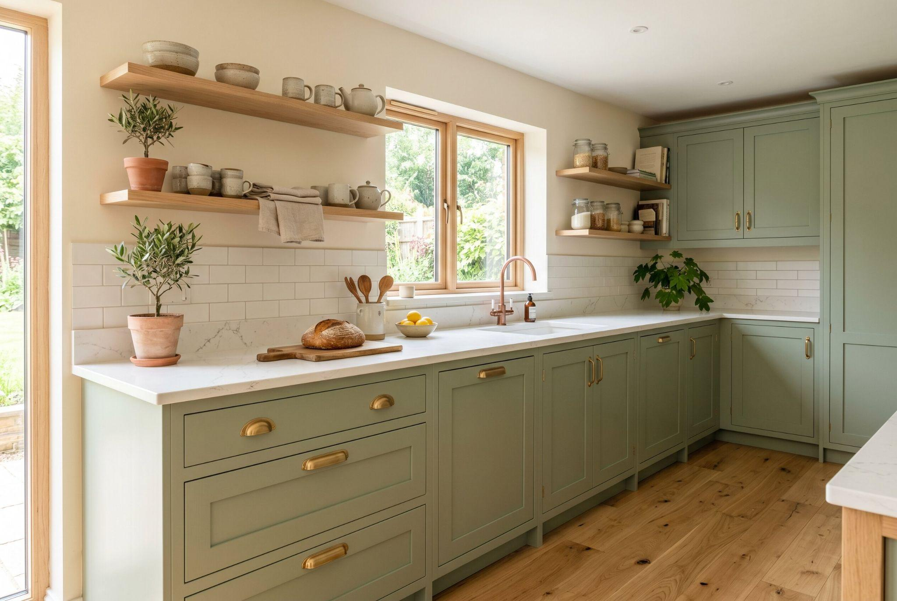
Bright sage green kitchen with open wood shelving, brass hardware, and natural oak flooring.
Sage green is one of the safest ways to add color without making the kitchen feel loud. It brings calm, softness, and a natural mood that works beautifully with brass pulls, cream walls, white quartz, and light oak floors.
This shade is especially strong for painted kitchen cabinets because it feels fresh but not risky. In a small kitchen, use sage on lower cabinets and keep the uppers white or open. In a larger kitchen, sage can cover all cabinets if the room has enough natural light. The result feels peaceful, updated, and easy to live with.

2. Timeless Two Tone Kitchen Cabinets
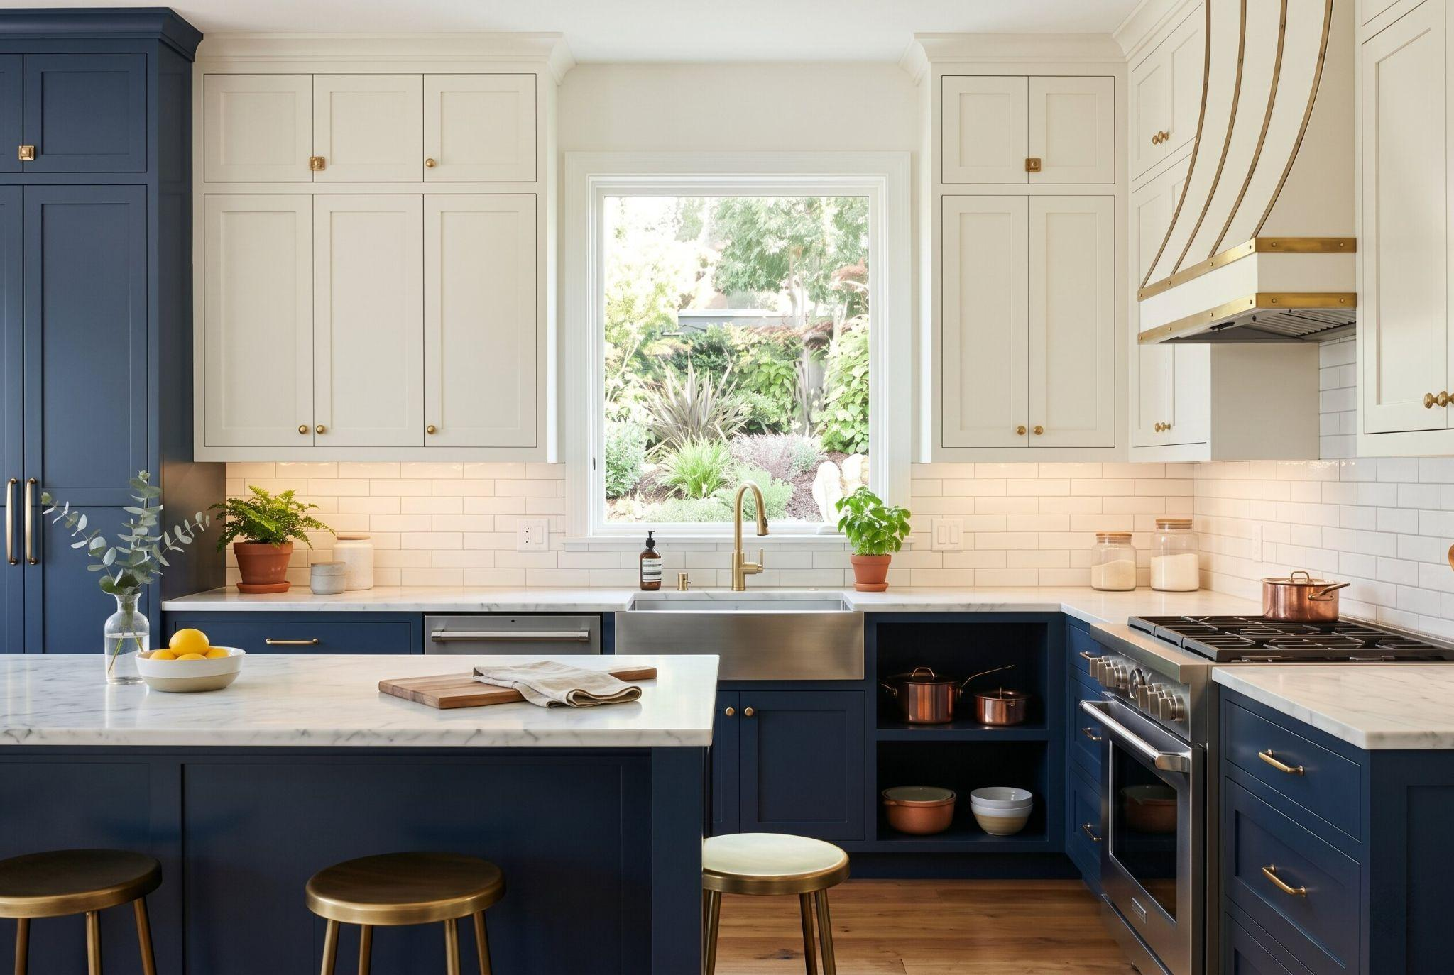
Classic navy and white kitchen with marble countertops, brass accents, and large center island.
Two tone kitchen cabinets remain popular because they solve a real design problem: balance. Darker lower cabinets ground the kitchen, while lighter upper cabinets keep the room bright and open.
This approach is perfect if you want depth but don't want the kitchen to feel heavy. Try navy lowers with warm white uppers, charcoal lowers with cream uppers, or deep green lowers with soft greige uppers. The horizontal contrast also makes ceilings feel taller, which is helpful in older kitchens or compact layouts.

3. Rich Walnut Paired With Matte Charcoal
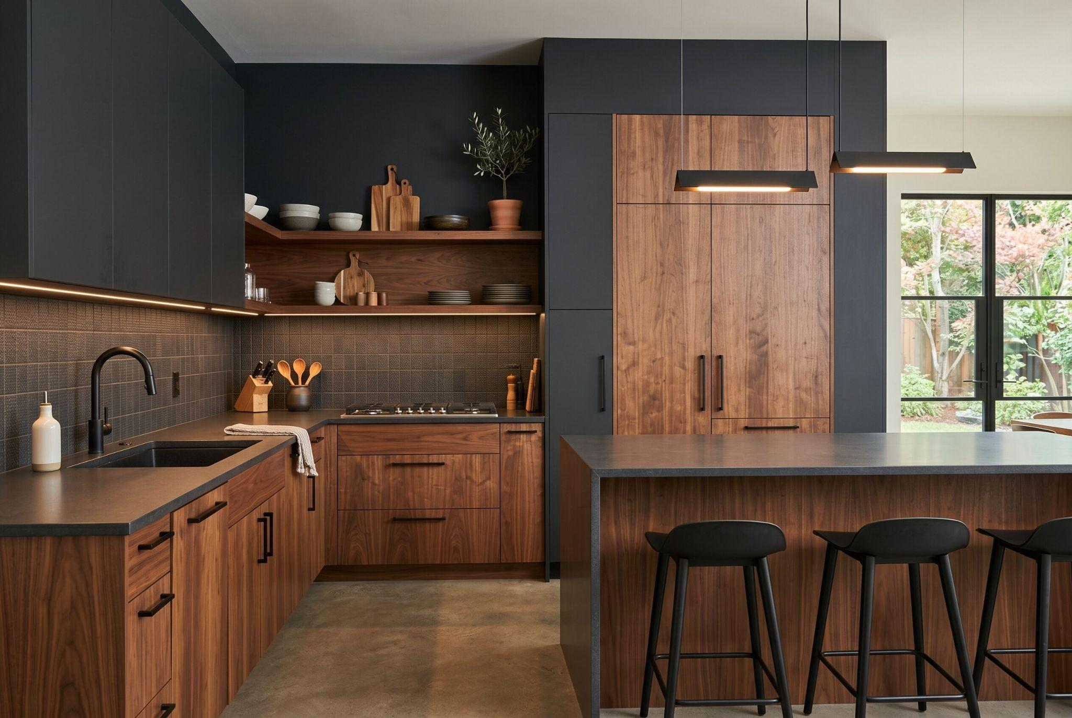
Modern dark wood kitchen with matte black cabinetry, sleek island, and ambient lighting.
Walnut and matte charcoal create a refined, architectural kitchen. Instead of painting every cabinet, keep some natural wood grain visible and pair it with a deep charcoal paint.
This idea works best when walnut appears on lower cabinets, a pantry wall, or open shelving. Matte charcoal adds modern contrast, while walnut prevents the kitchen from feeling cold. Use simple hardware and warm lighting so the palette feels intentional. This is a strong option for homeowners who want a modern kitchen that still feels warm.

4. The Bold Focal Point: Red Kitchen Cabinets
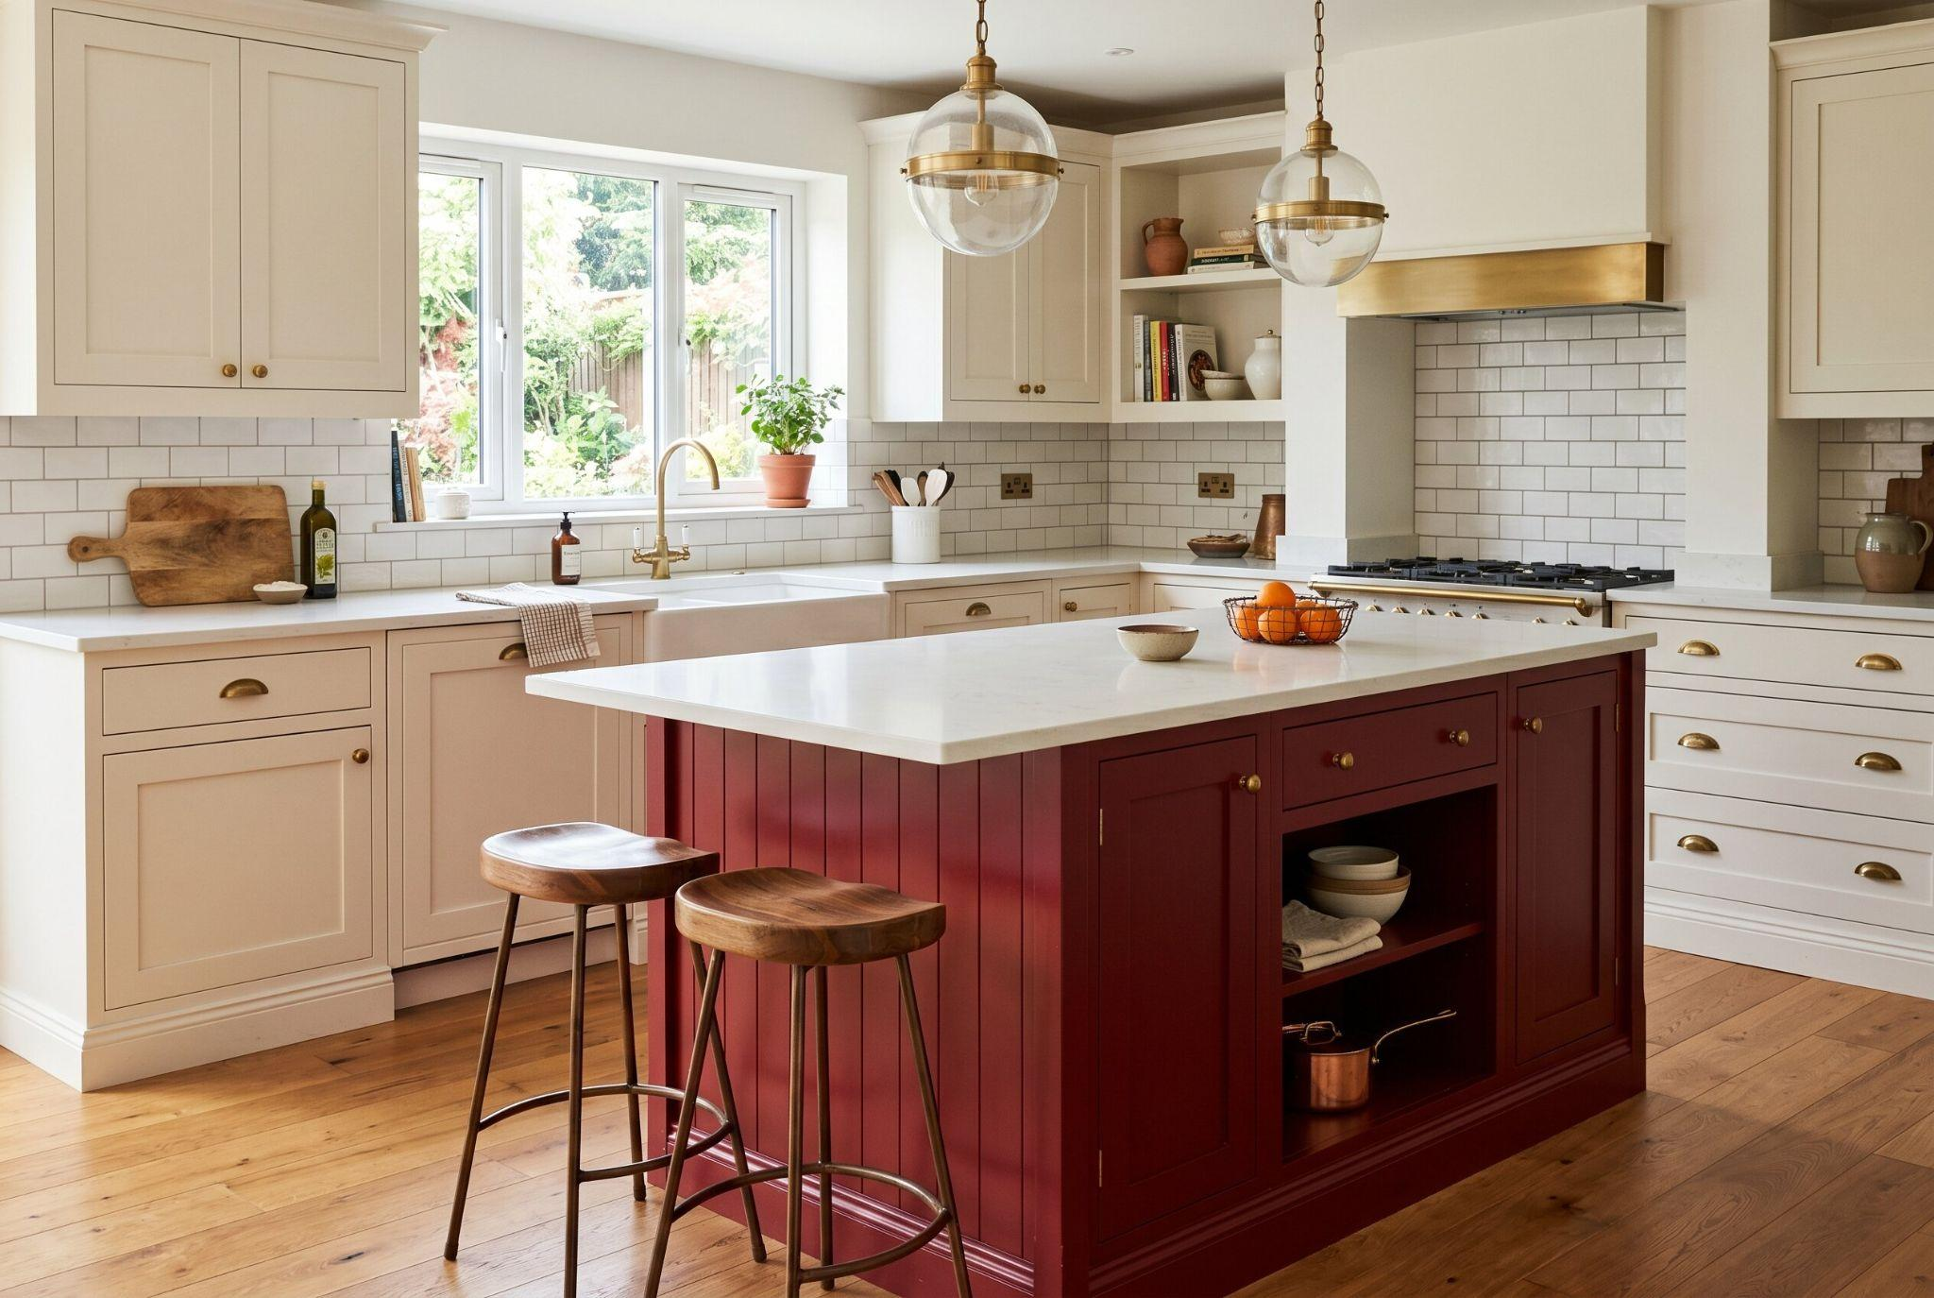
Elegant cream kitchen with burgundy island, brass fixtures, and bright natural light.
Red kitchen cabinets can be stunning, but the key is using red with control. Instead of painting every cabinet bright red, choose burgundy, terracotta, oxblood, or muted crimson for one focused area. A red island is the easiest place to start. It creates drama without overwhelming the entire room. Pair it with cream perimeter cabinets, walnut stools, white quartz, or aged brass hardware. Red works best when the surrounding materials are calm. This turns the color into a design feature rather than a visual shock.

5. Warm Mushroom and Greige Tones
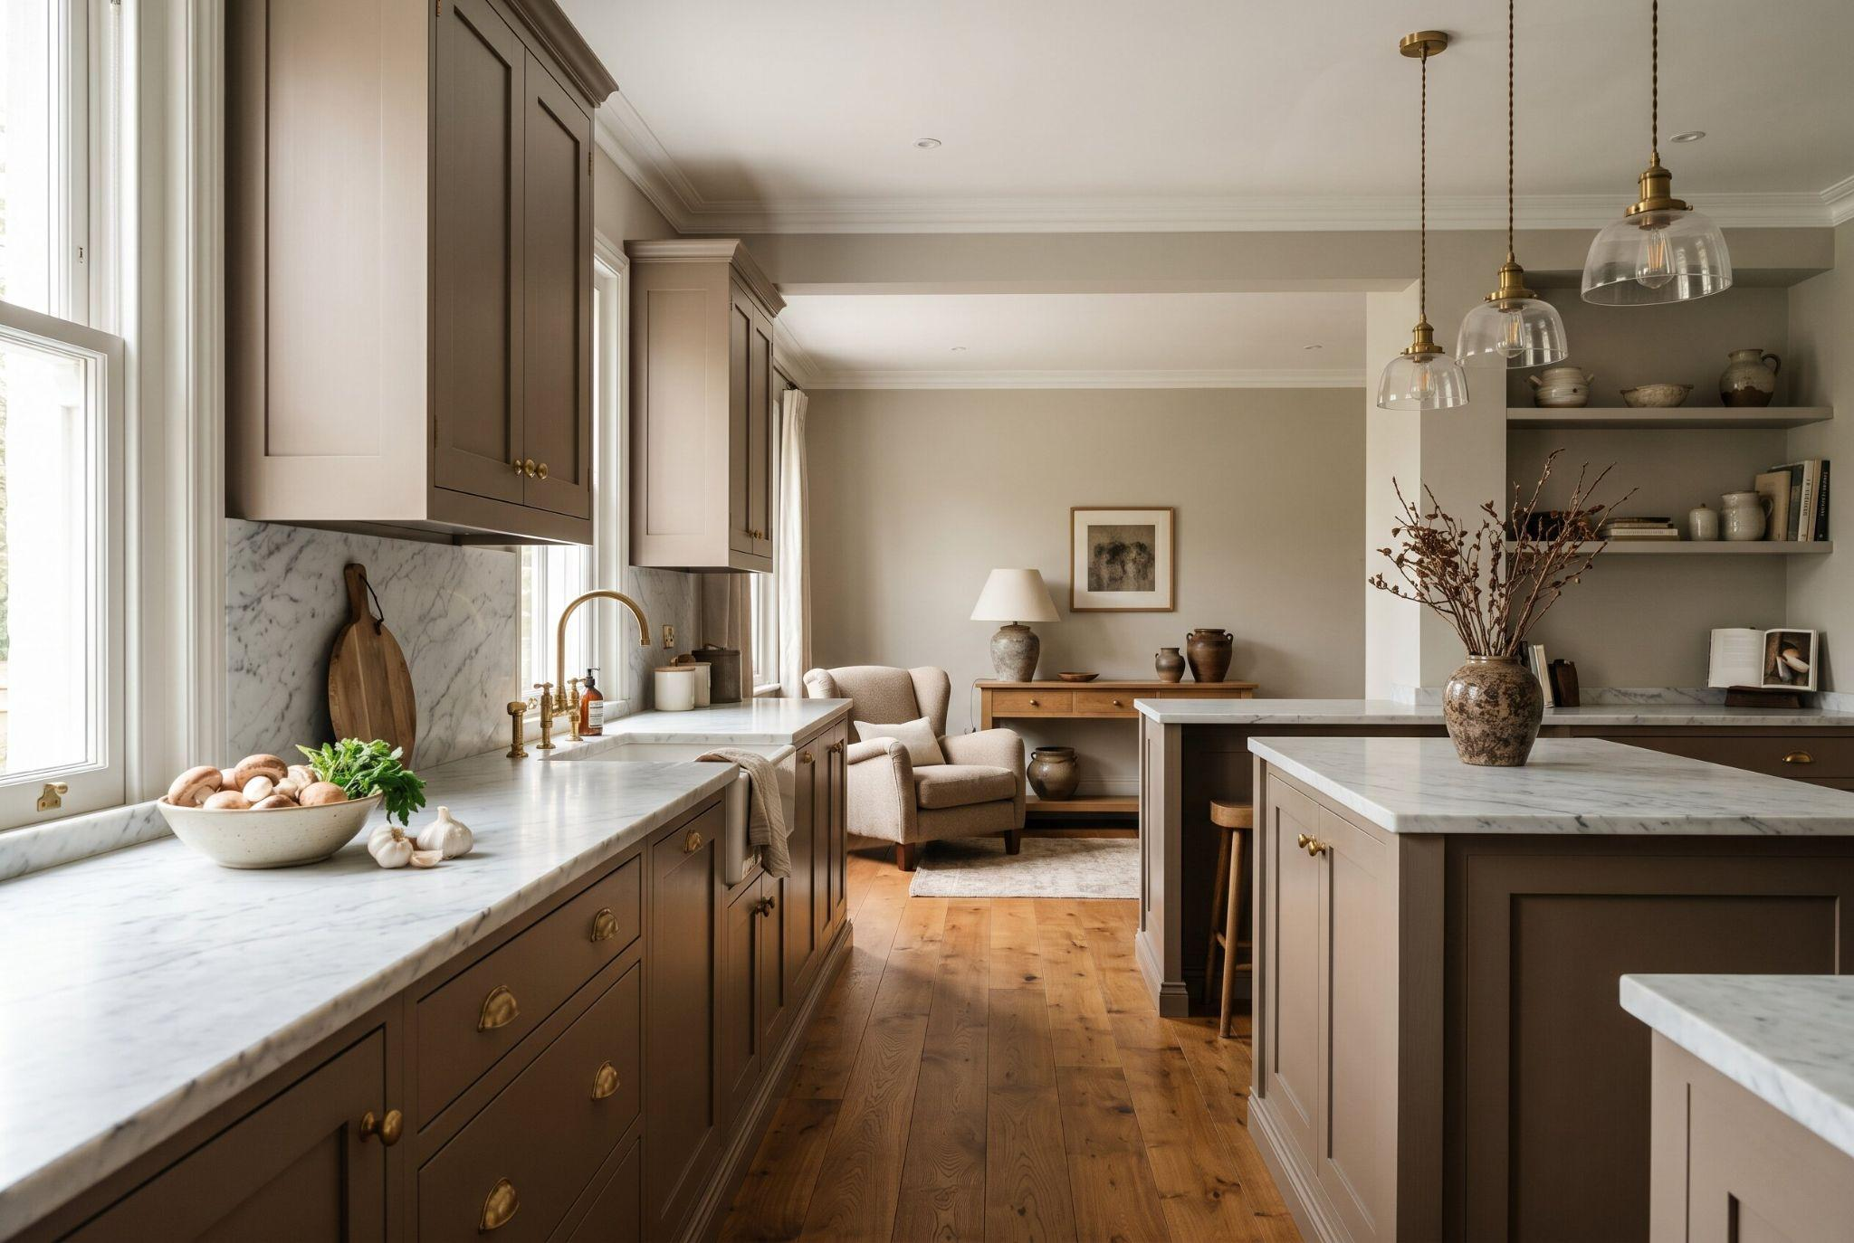
Sophisticated taupe kitchen with marble countertops, brass details, and cozy open-plan layout.
Mushroom and greige are perfect alternatives to cold white or flat gray. These colors have warmth, softness, and depth, which makes cabinets look more expensive. Mushroom painted kitchen cabinets work beautifully with stone counters, brushed nickel, brass, black hardware, and warm wood floors. Greige is especially useful if your kitchen connects to a living space because it blends easily with many wall colors. This is a low regret choice for homeowners who want a quiet but polished update.

6. Classic Navy Blue With Brushed Brass
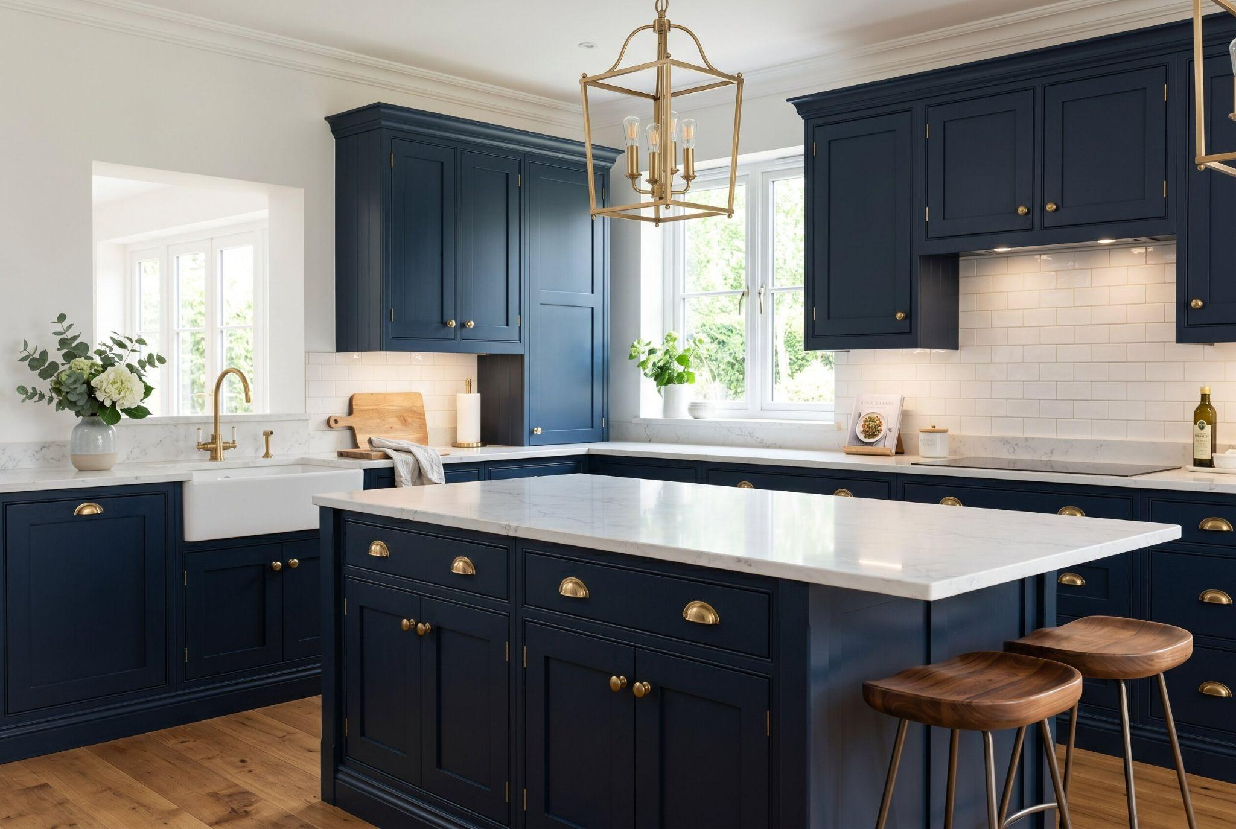
Luxurious navy blue kitchen with white marble island, brass hardware, and farmhouse sink
Navy blue cabinets feel timeless because they sit between classic and bold. They are rich enough to create contrast but familiar enough to avoid feeling trendy. Navy works beautifully on lower cabinets, islands, or a full wall of pantry cabinets. Brushed brass hardware warms the color and keeps the kitchen from feeling too formal. For a clean look, pair navy with white counters and simple backsplash tile. For a moodier look, add walnut accents and warmer lighting.

7. High Contrast 2 Tone Kitchen Cabinets
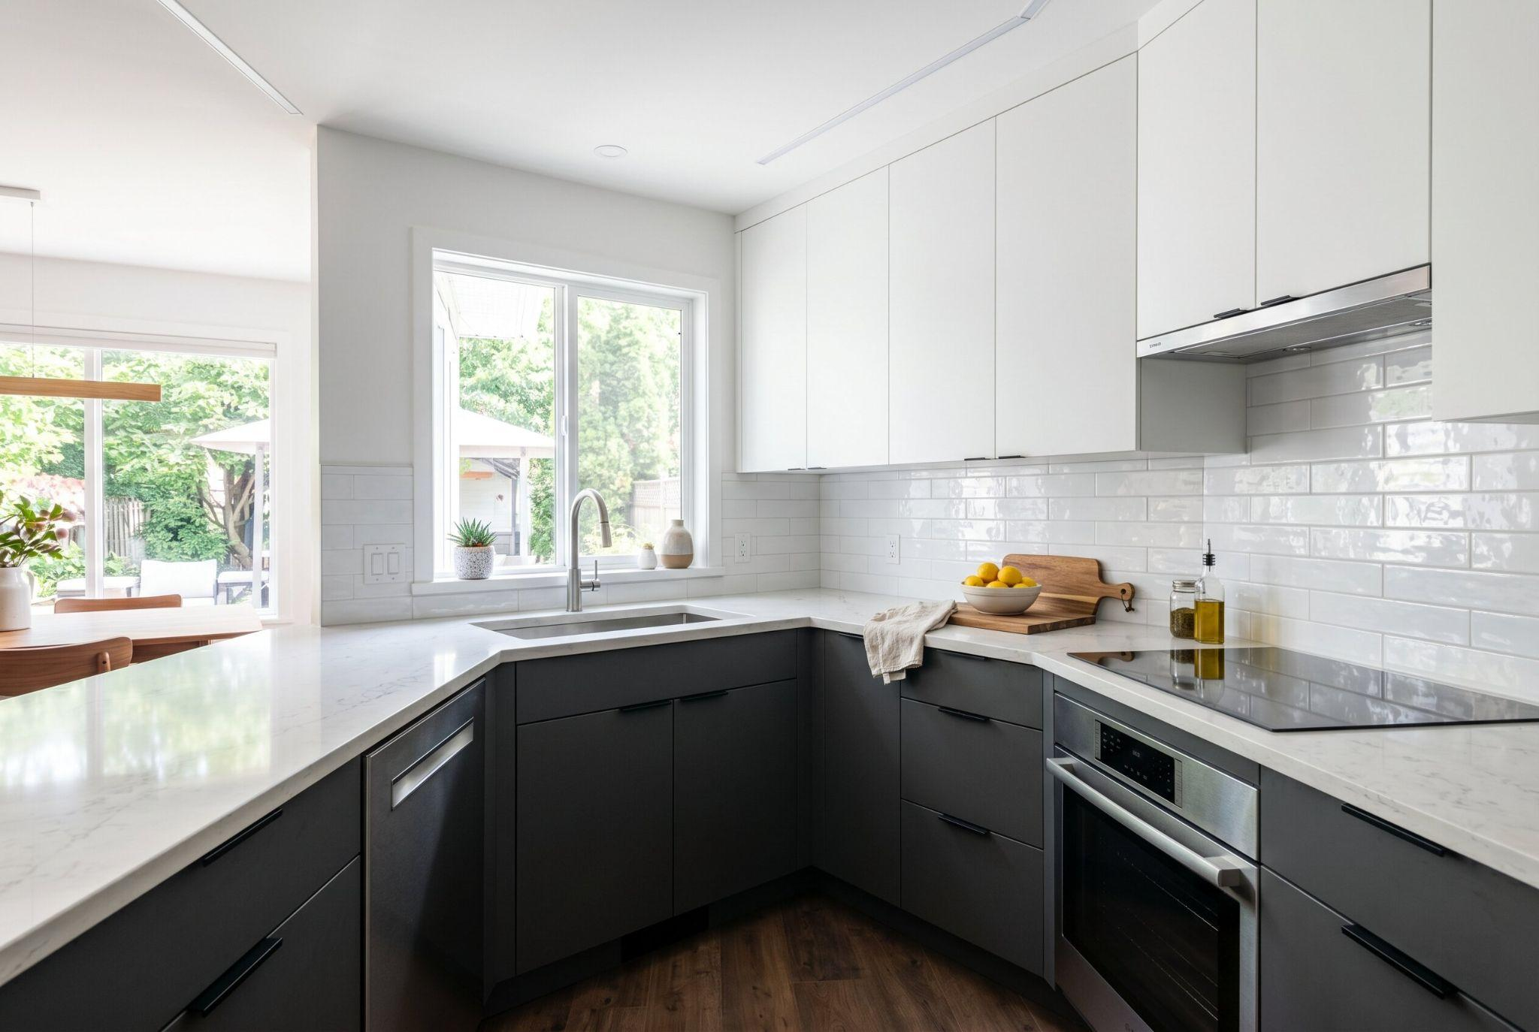
Minimalist black and white kitchen with glossy tile backsplash and sleek modern finishes.
High contrast 2 tone kitchen cabinets are ideal for modern kitchens. Think black lowers with white uppers, deep charcoal lowers with porcelain white uppers, or espresso cabinets paired with soft cream. The secret is keeping the lines clean. Flat front doors, minimal hardware, and simple counters help the strong contrast feel sleek rather than busy. This style works best when the kitchen has good lighting. Without enough light, dark lowers can feel heavy, so balance them with pale counters and reflective backsplash materials.

8. Crisp White Paired With White Oak Open Shelving
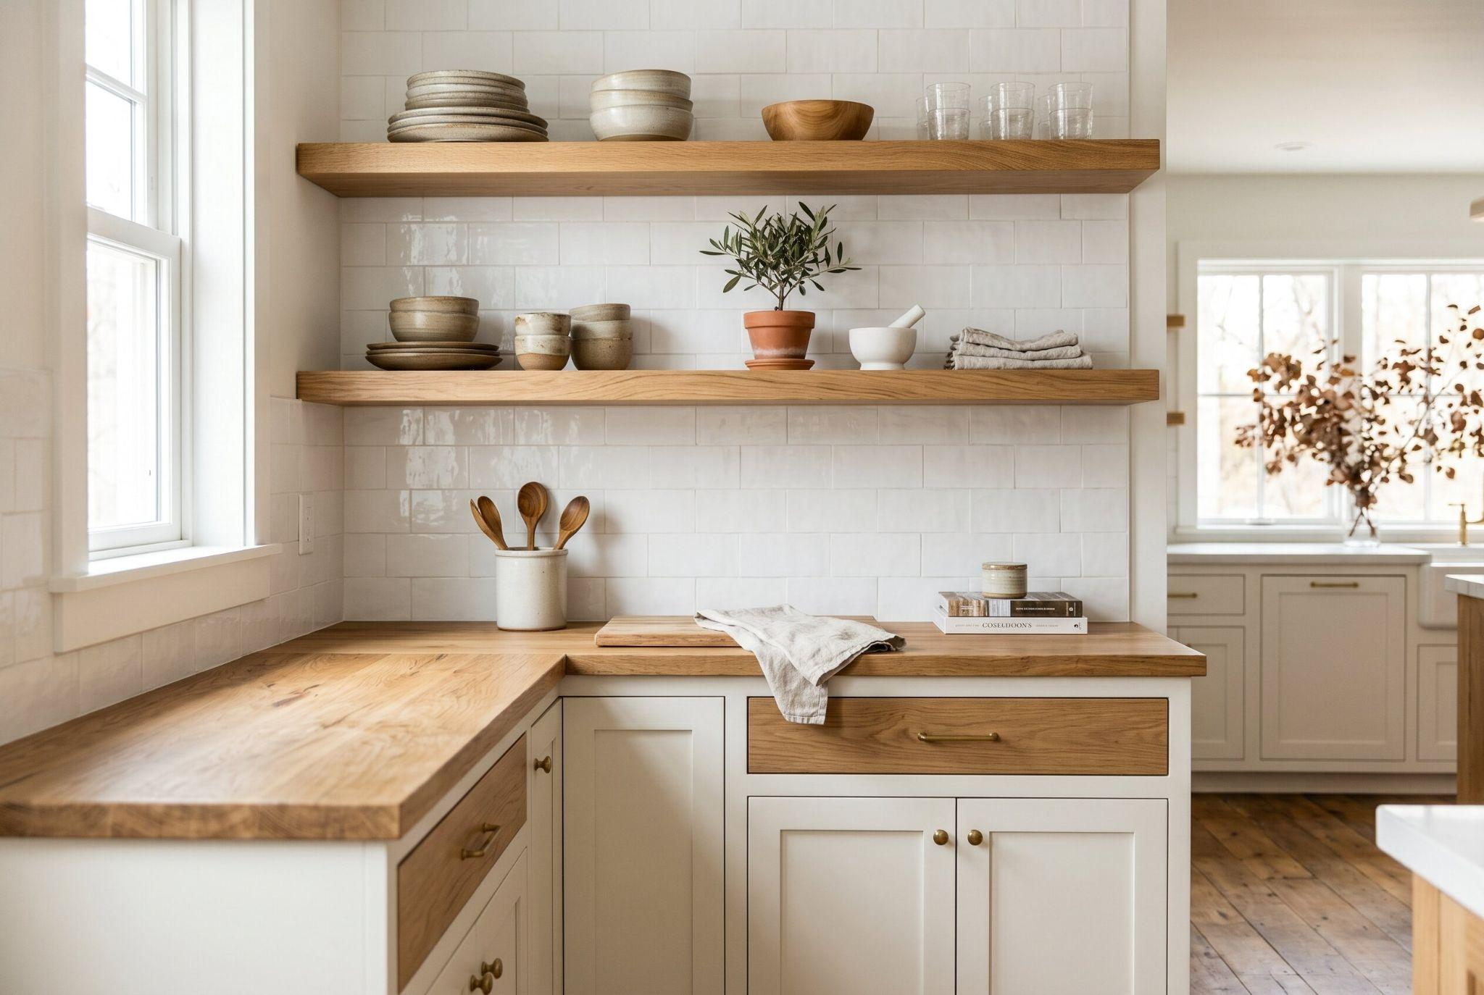
Cozy neutral kitchen with wood countertops, open shelving, and soft Scandinavian-inspired design.
White painted cabinets can still feel warm when paired with white oak open shelving. The white keeps the kitchen bright, while the oak adds texture and prevents the space from feeling sterile. This look works beautifully in farmhouse, Scandinavian, coastal, and modern organic kitchens. Use white paint with a soft warm undertone instead of a harsh blue white. Style the shelves with simple dishes, glassware, pottery, or wood bowls so the room feels calm and lived in.

9. Pastel Mint for a Vintage Cottage Feel
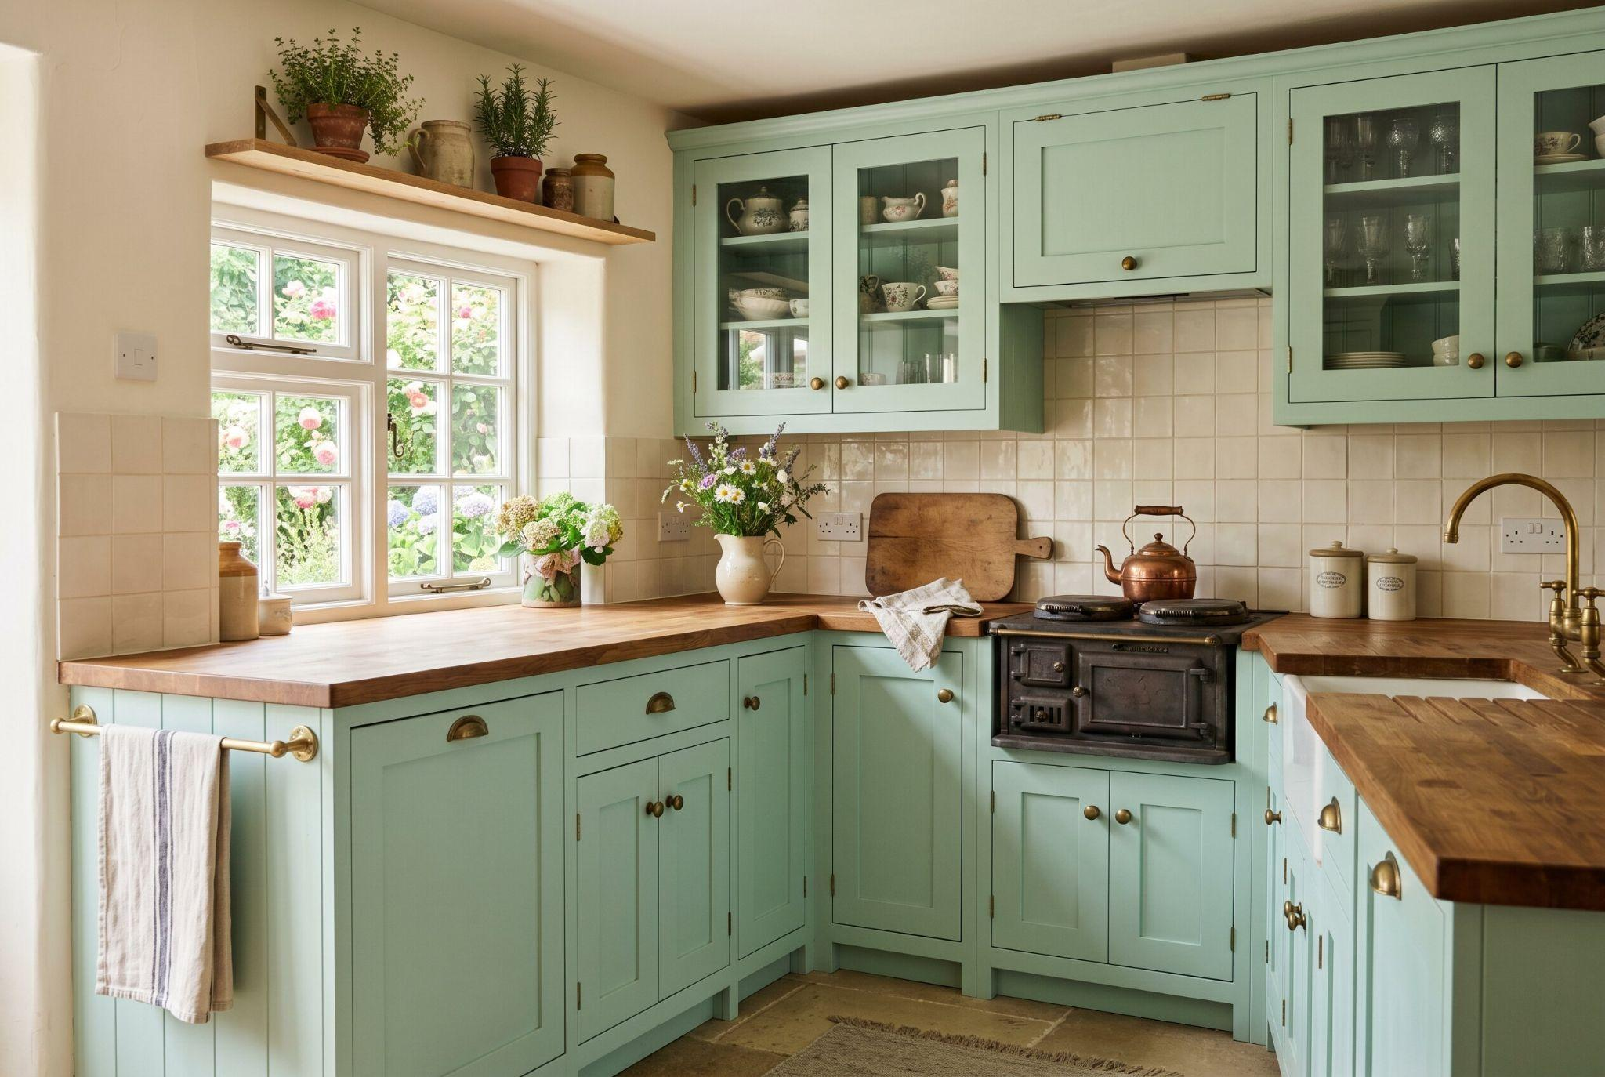
Charming mint green kitchen with wood countertops, vintage stove, and cozy cottage-style details.
Pastel mint brings a nostalgic cottage feeling to painted kitchen cabinets. It is soft, cheerful, and especially charming in smaller kitchens with natural light. To keep mint from looking childish, pair it with warm white walls, butcher block counters, vintage brass knobs, or simple ceramic tile. Mint works best when the rest of the kitchen feels restrained. It gives the room personality without the intensity of deeper green or blue.

10. Deep Forest Green for Maximum Drama
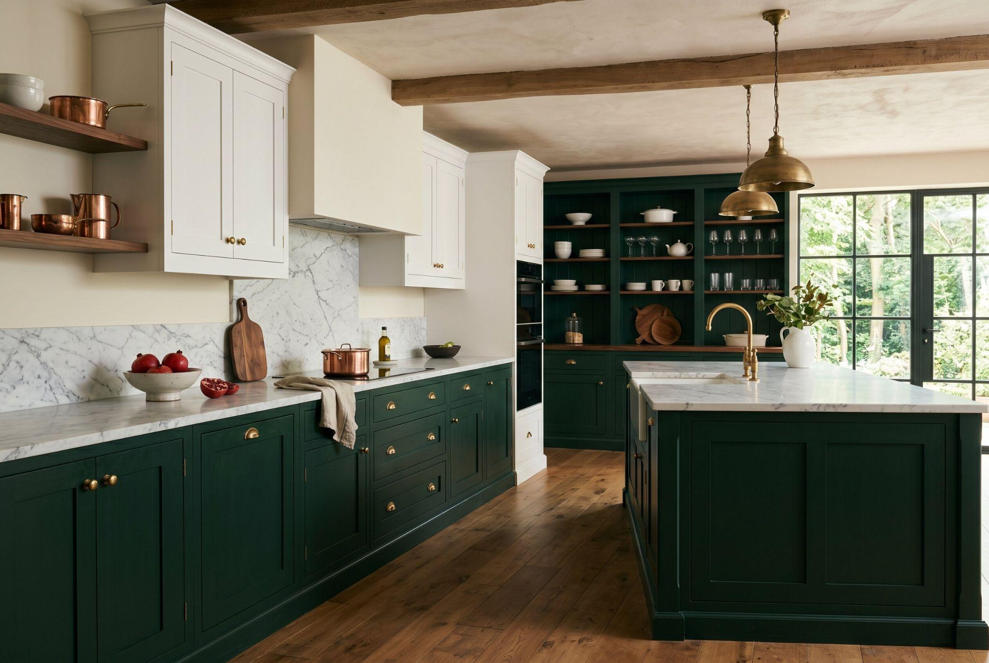
Elegant dark green kitchen with marble countertops, brass lighting, and warm wood flooring.

Deep forest green is rich, moody, and sophisticated. It works best in kitchens where you want the cabinets to feel like a major design statement. Pair forest green with white marble, cream quartz, unlacquered brass, walnut, or warm oak. This color looks beautiful on lower cabinets, built in pantry walls, or a dramatic island. If your kitchen is small, use forest green below the counter line and keep the upper area bright. This gives you drama without making the space feel closed in.

11. Soft Clay and Terracotta
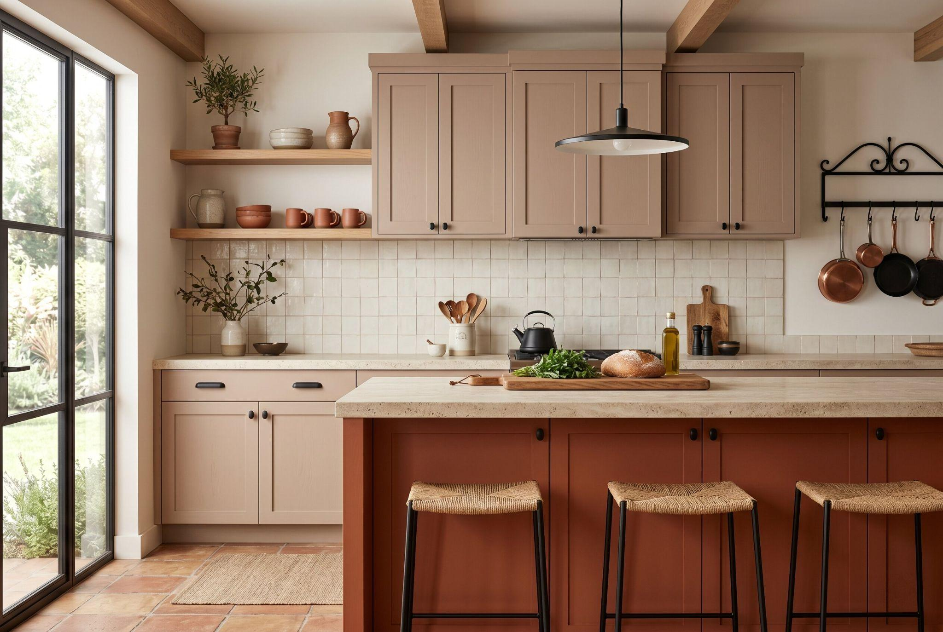
Rustic modern kitchen with taupe cabinetry, terracotta island, and open wood shelving.

Soft clay and terracotta are warm, earthy, and perfect for 2026 kitchens. These shades bring Mediterranean warmth without feeling too bright or trendy. Clay painted cabinets pair well with cream tile, natural stone, oak shelves, woven stools, and black accents. Terracotta is stronger, so it works best on an island or lower cabinets. These colors are especially useful in kitchens that feel too cold, because they add instant warmth and personality.

12. Dusty Blue for Coastal Kitchens
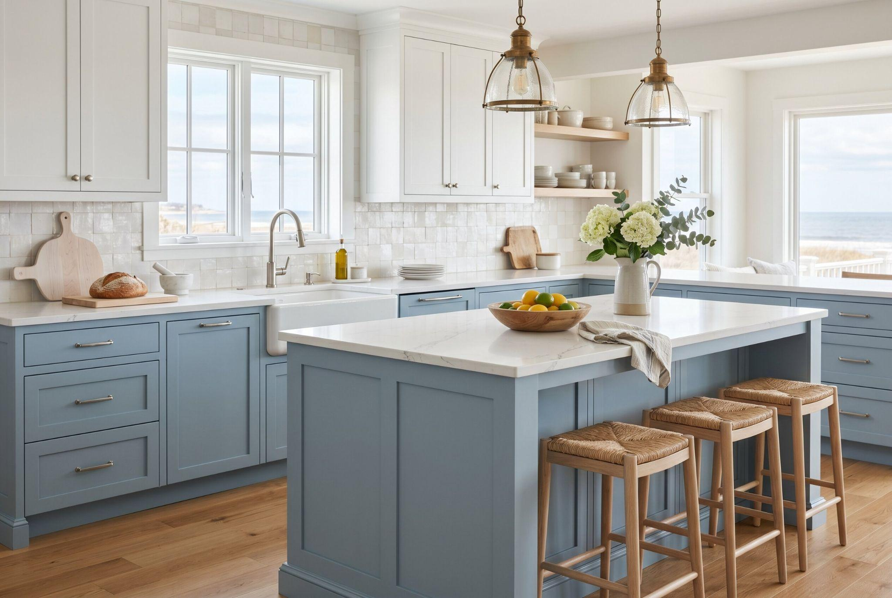
Coastal-inspired kitchen with soft blue cabinets, white island, and bright airy natural light.

Dusty blue is a softer alternative to navy. It feels relaxed, airy, and slightly weathered, making it ideal for coastal kitchens or homes that need a calmer color palette. Use dusty blue on lower cabinets with white uppers, or paint a kitchen island blue and keep the perimeter cabinets cream. This color pairs well with pale oak, brushed nickel, white quartz, and handmade tile. Avoid overly bright blue if you want a timeless look. A muted undertone keeps the kitchen elegant.

13. Elegant Two Tone Cabinets With Natural Wood
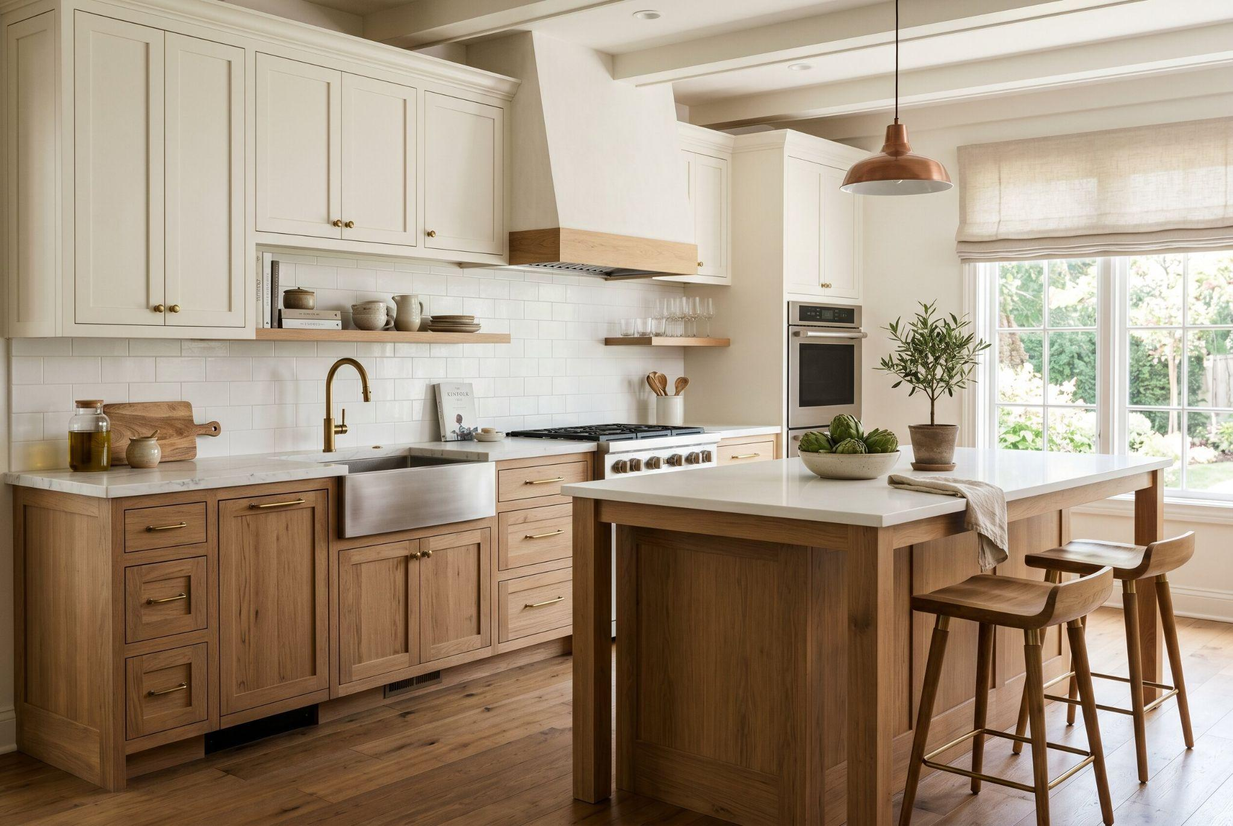
Bright farmhouse kitchen with natural wood cabinetry, white countertops, and warm minimalist design.
Two tone cabinets do not always need two paint colors. One of the most beautiful options is mixing painted cabinets with natural wood. Try soft white uppers with natural oak lowers, mushroom painted perimeter cabinets with a walnut island, or pale green cabinets with wood open shelving. The wood adds warmth and texture, while the painted finish gives the kitchen color and softness. This approach feels more custom than a fully painted kitchen and often ages better because the natural material brings depth.

4 Steps to Get a Factory Smooth Pro Finish

Clean and Degrease Cabinets
A great cabinet color will only look good if the finish is smooth and durable. First, remove doors and hardware, label everything, and clean every surface with a strong degreaser. Kitchen cabinets collect oil, steam, and fingerprints, and paint will not bond well to grease.

Sand and Prime Properly
Second, sand lightly so the primer has something to grip. You don't need to destroy the existing finish, but you do need to dull the surface. Third, use a bonding primer, especially on glossy, stained, laminate, or previously painted cabinets.

Choose the Right Paint and Tools
Fourth, choose self leveling enamel paint made for cabinets and trim. A foam roller can work for DIYers, but a sprayer gives the smoothest result. If you use a brush, use it only for corners and details, then smooth larger areas with a fine roller.

Allow Proper Drying and Curing
Let each coat cure fully before rehanging doors. Rushing this step can ruin the finish even if the color is perfect.

Conclusion
The best painted kitchen cabinet ideas for 2026 combine beauty with practical planning. Sage green, mushroom, dusty blue, clay, navy, forest green, and two tone kitchen cabinets can all transform a tired kitchen into a space that feels fresh and intentional.
But paint is not magic by itself. The real difference comes from preparation, primer, durable enamel, patient drying time, and colors that work with your counters, floors, backsplash, and lighting.
Before buying paint, test large samples in your kitchen throughout the day. If the shade still looks beautiful in morning light, afternoon shadow, and evening bulbs, you are much closer to a cabinet makeover that feels professional, personal, and worth the effort.

